Directions
- Carefully read the overhead projection for any additional directions specific to this quiz/exam.
- In the header, replace the highlighted text with your name and remove the highlight.
- Make your final answers clear, ideally with circles or in green. Correct answers made clear “after the fact” will not be graded.

- Any questions with an answer but no justifying work will be graded as incorrect.

- (Exceptions are made for those with accommodations requests.)
>>>>>> ALL TEXT OR OTHER FORMS OF ANSWERS WILL BE IGNORED!!!!!!!! <<<<<<<
>>>>>> THIS INCLUDES POWERPOINT AND OTHER VECTORIZED DRAWINGS !!!!! <<<<
X
- Violating any of these rules or other malicious behavior will result in a 0 grade and disciplinary action report to the provost’s office.
- Partial credit is awarded for flawed work or answering the question outside of given constraints: do not leave an answer blank if you can answer a similar question.
- Any indication of copied work, especially identical incorrect answers or identically formatted answers will 1) be marked as incorrect and 2) be referred to the Provost’s Office for academic misconduct.

 | Expression | Dual
P2 | $$a+0=a$$ | $$a⋅1=a$$
P3 | $$a+b=b+a$$ | $$ab=ba$$
P4 | $$a+\left(b+c\right)=\left(a+b\right)+c$$ | $$a\left(bc\right)=\left(ab\right)c$$
P5 | $$a+bc=(a+b)(a+c)$$ | $$a\left(b+c\right)=ab+ac$$
P6 | $$a+\overline{a}=1$$ | $$a⋅\overline{a}=0$$
T1 | $$a+a=a$$ | $$a⋅a=a$$
T2 | $$a+1=1$$ | $$a⋅0=0$$
T3 | $$\overline{\overline{a}}=a$$
T4 | $$a+ab=a$$ | $$a\left(a+b\right)=a$$
T5 | $$a+\overline{a}b=a+b$$ | $$a\left(\overline{a}+b\right)=ab$$
T6 | $$ab+a\overline{b}=a$$ | $$\left(a+b\right)\left(a+\overline{b}\right)=a$$
T7 | $$ab+a\overline{b}c=ab+ac$$ | $$\left(a+b\right)\left(a+\overline{b}+c\right)=(a+b)(a+c)$$
T8 | $$\overline{a+b}=\overline{a}\overline{b}$$ | $$\overline{ab}=\overline{a}+\overline{b}$$
T9 | $$ab+\overline{a}c+bc=ab+\overline{a}c$$ | $$\left(a+b\right)\left(\overline{a}+c\right)\left(b+c\right)=(a+b)(\overline{a}+c)$$
T10(a) | $$f\left(x_{1},x_{2},…,x_{n}\right)=x_{1}⋅(f\left(1,x_{2},…,x_{n}\right)+\overline{x_{1}}⋅f(0,x_{2},…,x_{n})$$
T10(b) | $$f\left(x_{1},x_{2},…,x_{n}\right)=\left[x_{1}+f\left(0,x_{2},…,x_{n}\right)\right]\left[\overline{x_{1}}+f\left(1,x_{2},…,x_{n}\right)\right]$$

Problem 1 (6 points)
For the following circuit, complete the timing diagram provided. All signals are equally graded. You may annotate the timing diagram as you see fit.

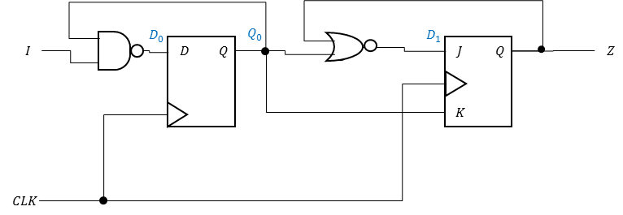

CLK
I
D0
Q0
D1
Z

Problem 2 (5 points)
Create the state diagram for a machine which detects the input sequence “1 0 1”. The output must be 1 immediately when the sequence is detected and can change between clock cycles. Overlapping sequences are detected.
The drawings given bellow are for your convenience: not all parts or text may be needed. Please cross out all unused parts in a unique color to ensure they are not graded.
/
/
/
/
/
/
/
/
/
/
/
/

Problem 3 (8 points)
Create the following FSM using J-K flip flops. A table and K-maps are provided for your convenience, as are boxes for flip-flops. You may not need to use all provided K-maps or hardware elements. The final score is based on optimality.
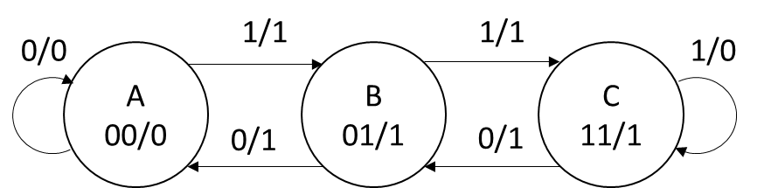

1
0

Problem 4 (5 points)
Make a 1-hot implementation of the FSM from the previous problem (repeated below). Make this machine using D flip-flops with active-low $\overline{PRE}$ and $\overline{CLR}$ and a global active-high $RST$. Presume the machine resets to the “A” state. The beginnings of D flip-flops are provided on the next page, but you need not use all flip-flops. The final score is based on optimality.

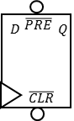

Problem 5 (3 points)
Create a 3-to-5 active-high decoder with an active-high enable. Name your inputs $\{x_{2},x_{1}, x_{0}, E\}$ (with $x_{0}$ as the LSB).

Problem 6 (3 points)
Realize the expression $Y=\overline{A}\overline{B}\overline{C}D+\overline{A}\overline{B}C\overline{D}+\overline{A}\overline{B}CD+A\overline{B}\overline{C}D+AB\overline{C}\overline{D}+ABC\overline{D}+AB\overline{C}D$ using a minimal number of 2-to-1 multiplexers.

Problem 7 (3 points)
Create a 4-bit constant (always) subtractor using NAND and XOR gates. This subtractor has 3 additional 1-bit outputs, G, L, and E, where are 1 when $A>B, A<B$ and $A=B$, respectively.

